Assignment 0

1. **Create a simple shell script to tell the user about their session – they need to know:** - What their username is

* What the current date is
* What the time is
* What their current working directory is
* How many files they have in that directory
* What is the biggest file in their current directory

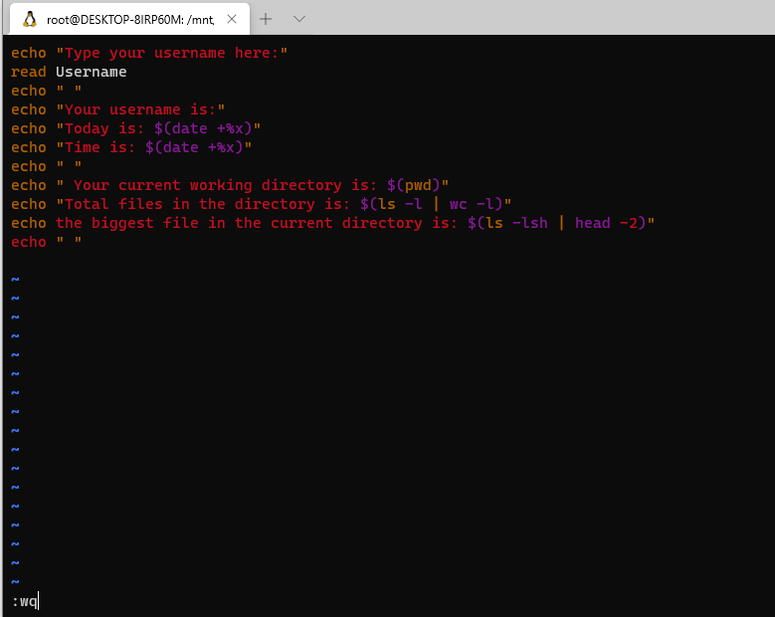

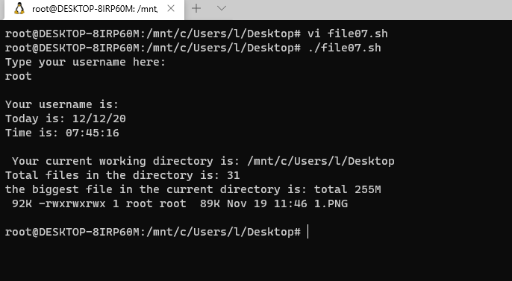

Assignment 1

**Create a directory with a few test files in it (the files can be empty). Now write a script that for every file in that directory you rename it to have an extension of today's date in YYYYMMDD format.**

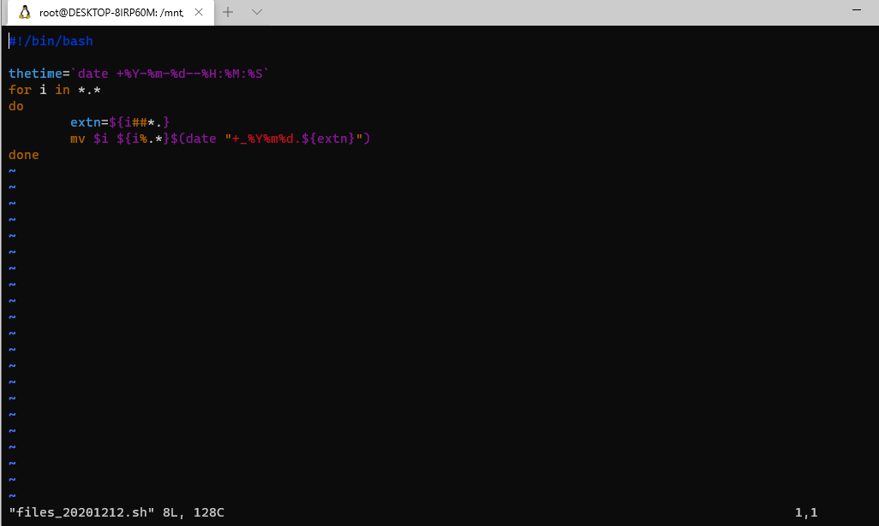

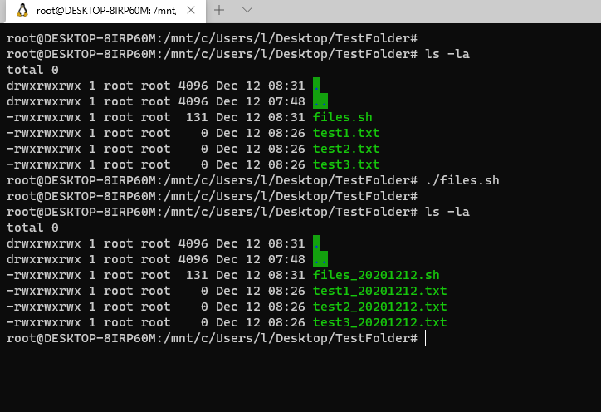

Assignment 2

**Write a script that takes a number as an input and reverses it out to the user. For example, if the original number is 74985, the output should be 58947.**

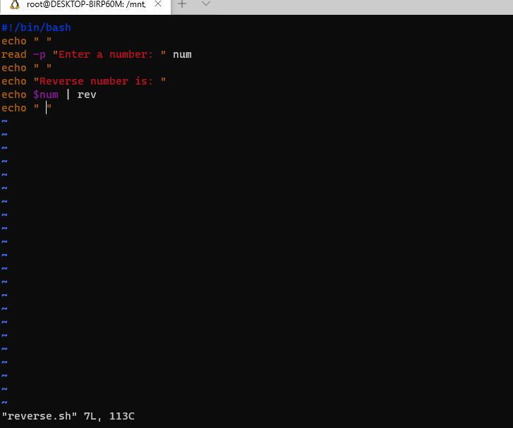

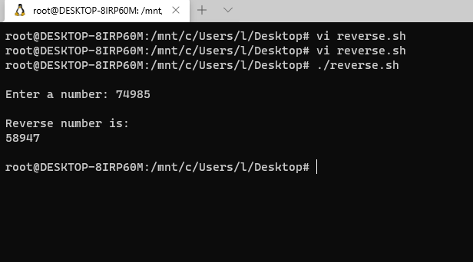

Assignment 3

**Write a script to validate how secure someone's password is. Things you would care about:**

* Length should be 8 or more characters
* The password should contain numbers and letters
* There should be both uppercase and lowercase letters

